Low Level Design (LLD)
Jal Rekha Project – Nirmal Module (Water Quality Monitoring)
Prepared By: Rupa Malviya
Module: Nirmal (Quality of Water)

1. Introduction – Nirmal for Quality of Water
The Nirmal Module ensures water quality across various schemes to provide safe drinking water. It supports regular water quality testing to detect contaminants and pollutants.
Nirmal is a dedicated module within the Jal Rekha Project for water quality monitoring. Field Engineers collect water samples and submit them to contractor laboratories for testing. Laboratory reports are uploaded into the system, enabling:
- Quality tracking
- Alert generation for unsafe samples
- Transparent sharing of results with citizens
This ensures continuous monitoring and compliance with drinking water quality standards.

2. System Architecture Overview
2.1 Technology Stack
- Frontend: ASP.NET (Web Dashboard, GIS Visualization)
- Mobile Application: Android (Core Java/Kotlin)
  - Offline Sync using SQLite / Local Storage
- Backend: RESTful WCF Services (.NET)
- Database: PostgreSQL with PostGIS (Spatial Data)
2.2 Infrastructure & Security
- Web Server: IIS
- Authentication: JWT Tokens
- Authorization: Role-Based Access Control (RBAC)
Hosting: In-House Cloud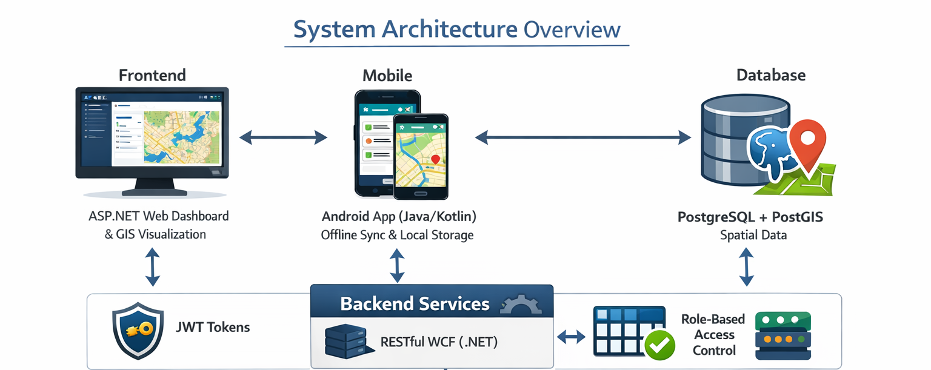

3. Module-wise Design Summary
Module: Nirmal (Water Quality Monitoring)
Responsibilities:
- Monitor water quality
- Water sample collection
- FRC testing and image capture
- Laboratory testing and QA/QC
- Alert generation for unsafe samples
Reports Generated:
- Beneficiary Water Quality Report
- OHT Water Quality Report
- WTP Water Quality Report
- Raw Water Test Report

4. Entity Relationship (ER) Diagram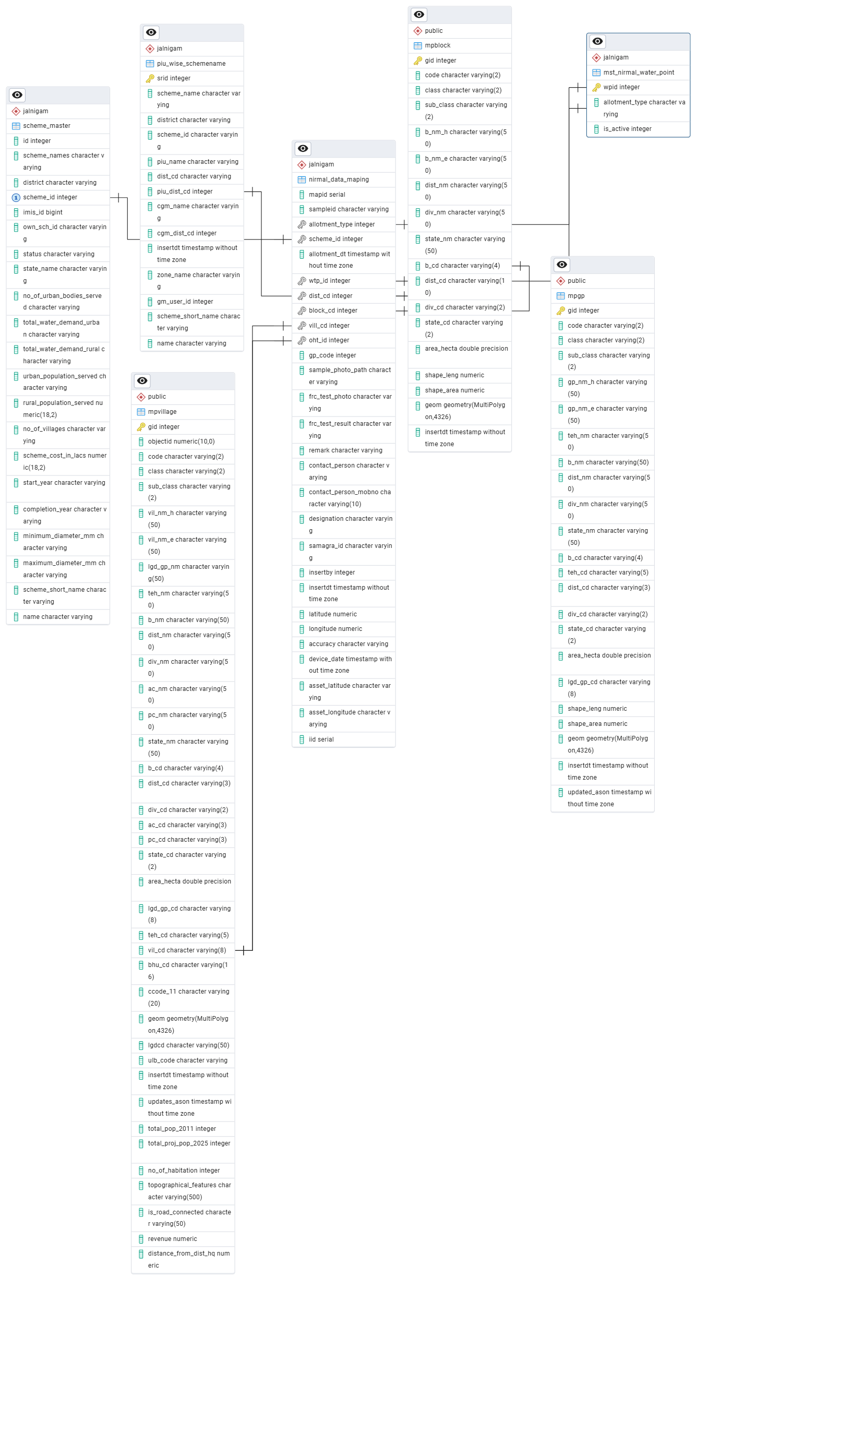
Figure: Simplified ER diagram showing core tables and relationships.
The system stores water sample data in a centralized structure. Each sample record is linked to:
- User: Who collected the sample
- Source Location: Beneficiary / OHT / WTP / Raw Water
For every sample, the following data is captured:
- FRC test result
- Images as proof
- Date and geo-location
Samples are mapped to a contractor laboratory for testing. Based on lab results, the system updates the Pass / Fail status.
Key Tables:
- nirmal_data_maping – Sample information, FRC results, photos, location
- scheme_master – Scheme information
- piu_wise_schemename – PIU-wise scheme mapping
- mst_nirmal_water_point – Master water points
- users, dhara_assigne_user_to_survey – User & survey assignments
- mpblock, mpvillage, mpgp – Geographic master tables
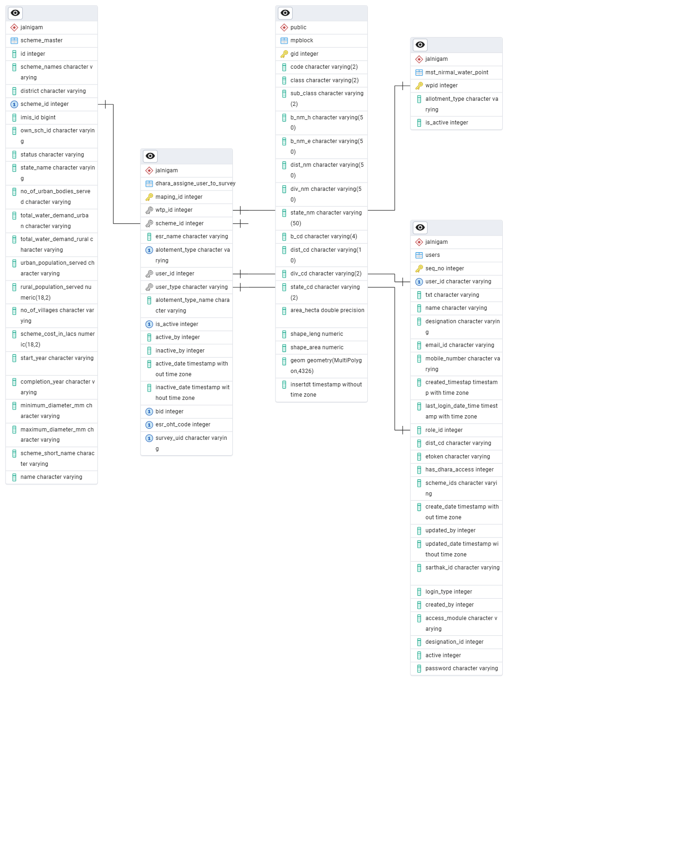
Figure: Assign User to Survey

5. Sequence Diagram – RFI Workflow
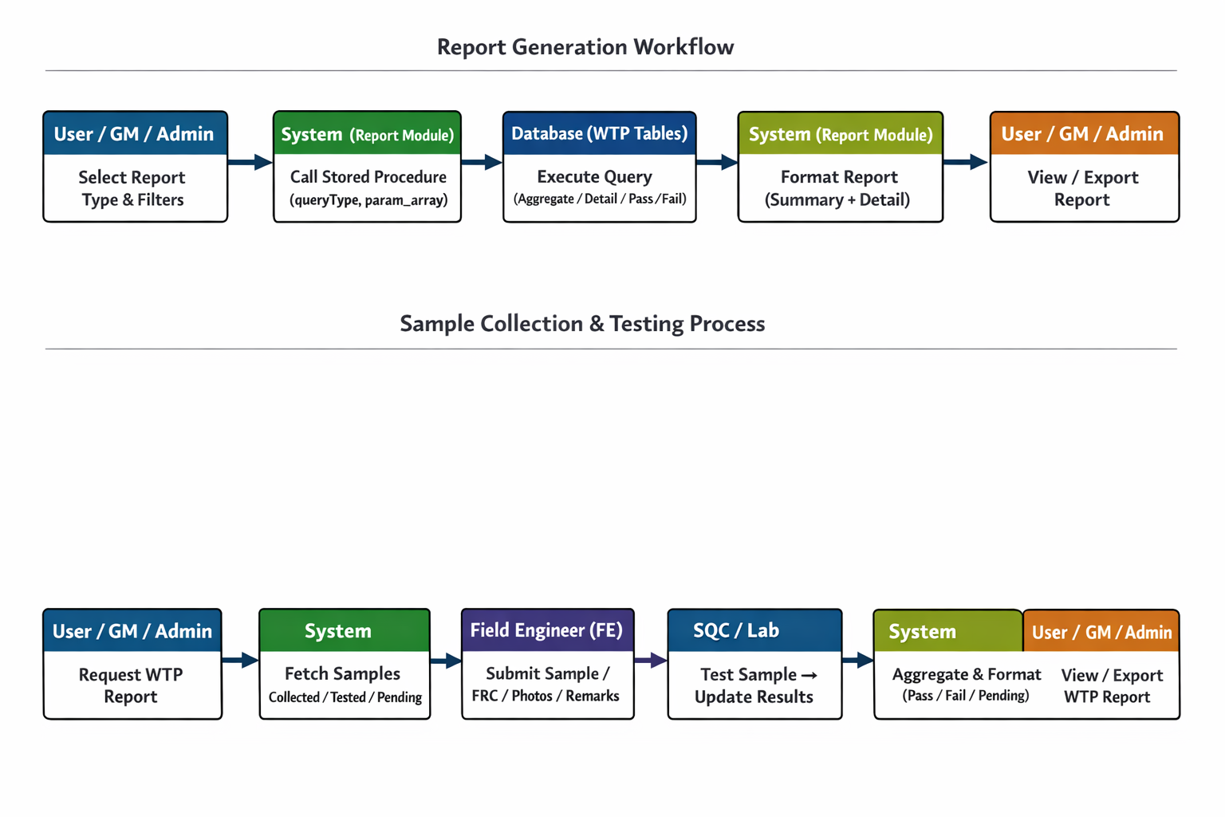

6. Sequence Diagram – Meter Reading Workflow
Scenario:
Field Engineer reads a meter, submits the reading, system updates data, and Admin/GM views reports.
This sequence illustrates step-by-step interaction between:
- User
- System
- Field Engineer
Database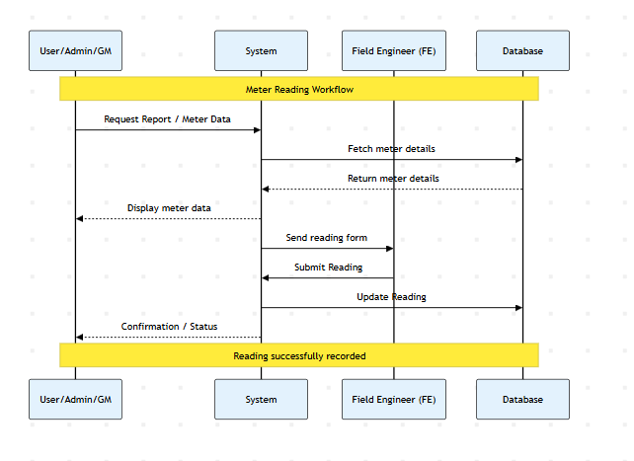

7. Report-wise Validation Logic (Pass / Fail)
The system determines the status of a water sample based on BIS 10500:2012 Drinking Water Standards.
7.1 Pass / Fail Criteria Table
All four reports (Beneficiary, OHT, WTP, Raw Water) follow the same validation logic:
Parameter | Acceptable Limit (PASS)
pH Value | 6.5 – 8.5
Turbidity | 0 – 5 NTU
Residual Chlorine | 0.2 – 1.0 mg/l (Minimum 0.2 required)
Total Dissolved Solids (TDS) | 0 – 2000 mg/l
Total Coliforms & E. Coli | 0 (Must be Absent)
Fluoride (as F) | 0 – 1.0 mg/l
Iron (Fe) | 0 – 1.5 mg/l
Taste & Odour | Unobjectionable

8. Core Reports
8.1 Beneficiary Quality Report
- Source: Consumer households
- Key Data: Samagra ID, Beneficiary Mobile Number, FRC Field Photo
- Purpose: Tracks last-mile water quality delivery
8.2 OHT (Overhead Tank) Quality Report
- Source: Distribution reservoirs
- Mapping: ohsr_code, vill_cd
- Purpose: Detect contamination during storage or secondary chlorination
8.3 WTP (Water Treatment Plant) Quality Report
- Source: Post-treatment outlet
- Mapping: wtp_id
- Purpose: Monitor filtration and chemical treatment efficiency
8.4 Raw Water Test Report
- Source: Intake wells / dams
- Purpose: Establish baseline water quality before treatment

9. Rectification & Replicated (Fail–Fix) Report
This report tracks samples that initially FAILED but were later corrected.
Rectification Workflow:
- Sample marked as FAIL
- System triggers alert to PIU / Contractor
- Contractor performs corrective action (chlorination / cleaning)
- Replicated sample submitted
- GM reviews results
- If compliant, sample moved to Rectified Samples dashboard count

10. Class Diagram (Simplified)
User
- userId : int
- name : string
- role : string
Methods: login(), requestReport()
Field Engineer
- feId : int
- zone : string
Methods: submitReading()
Meter
- meterId : int
- location : string
- lastReading : float
Methods: updateReading(), getReading()
Reading Report
- reportId : int
- readings : List
Methods: generateReport()
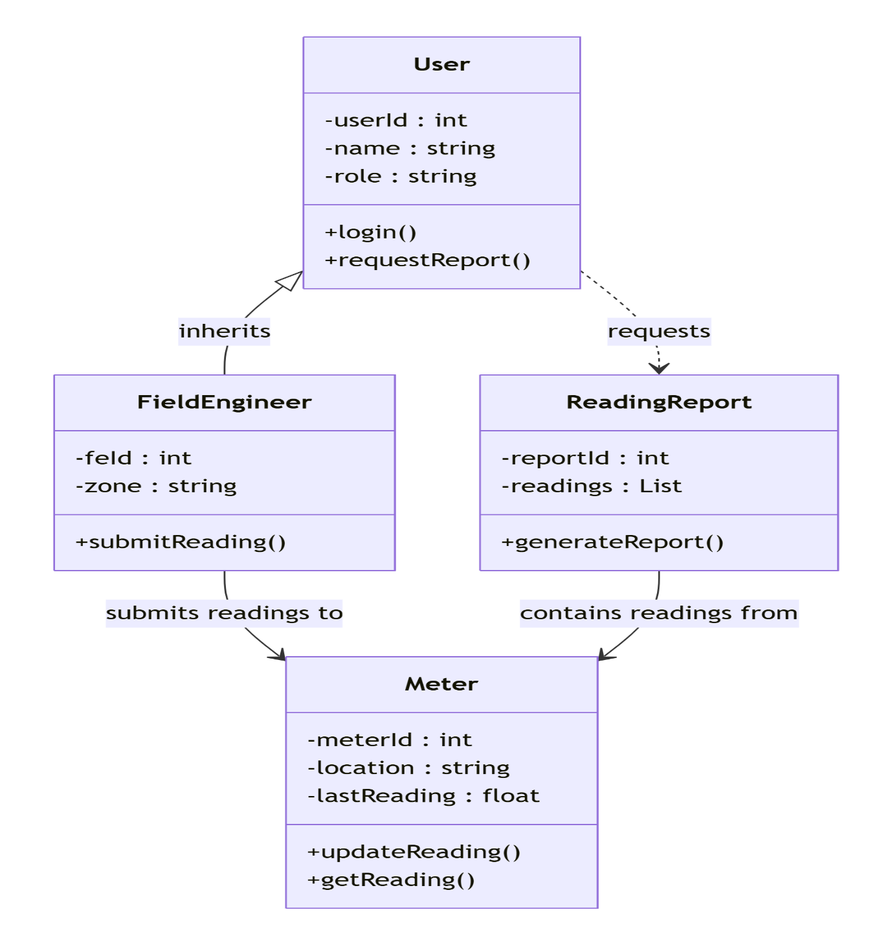

11. API Contracts
11.1 Web API – Beneficiary Report
GET /api/reports/beneficiary?scheme_id=1&date=2025-11-26
Response:
{
"status": "success",
"scheme": "Agar Malwa",
"date": "26-Nov-2025",
"total_samples": 3,
"samples": [
{
"Sample_Id": "WS28261125133027",
"Name_of_beneficiary": "bane singh",
"Beneficiary_mobile_no": "9009513661",
"Block": "Susner",
"Gram_Panchayat": "Gundlavda",
"Village": "Gundlawada",
"Date_of_sample_collection": "26-Nov-2025",
"Date_of_sample_submission": "26-Nov-2025 13:32:20",
"FRC_test_result_from_field": "0.2",
"FRC_test_photo_from_field": "Nirmal/frc_test_photo/2025_11_26/WS28261125133027/WS28261125133027_frc_photo_ImgS.jpg",
"Sample_collected_from": "Beneficiary",
"Name_of_Engineer": "balram singh",
"Remarks": ""
},
{
"Sample_Id": "WS28261125130534",
"Name_of_beneficiary": "Govt primary school bajna",
"Beneficiary_mobile_no": "9098334321",
"Block": "Susner",
"Gram_Panchayat": "Bajna",
"Village": "Bajna",
"Date_of_sample_collection": "26-Nov-2025",
"Date_of_sample_submission": "26-Nov-2025 13:06:48",
"FRC_test_result_from_field": "0.4",
"FRC_test_photo_from_field": "Nirmal/frc_test_photo/2025_11_26/WS28261125130534/WS28261125130534_frc_photo_ImgS.jpg",
"Sample_collected_from": "Beneficiary",
"Name_of_Engineer": "balram singh",
"Remarks": ""
}
]
}
11.2 Mobile APIs
Submit Water Sample Data
POST /api/mobile/water/submit
Purpose: Field Engineer submits water sample data including FRC results, geo-location, and photos.
Get Sync Data for Nirmal
POST /api/mobile/water/getsyncdata
Request:
{
"etoken": "B5ZPNGVSdNH1pgcc074Fv15m2vLXP12do1foBgX15PopXDM8S800L6MtG9Wz4LA8Wv8jNLJtR0d0fqQ8XpDx56el86bgb2UCy2x7",
"frc_test_result": "24",
"sampleid": "WS857200126131334",
"contact_person": "Anand test",
"oht_id": "471365",
"latitude": 23.2435797,
"allotment_type": 5,
"accuracy": "10.305",
"asset_longitude": 77.4302933,
"remark": "testing oht beneficiary",
"allotment_dt": "07/21/2025 13:36:07",
"sample_photo_Base64": "",
"samagra_id": "123654789",
"designation": "",
"vill_cd": 471365,
"asset_latitude": 23.2439049,
"longitude": 77.4298838
}
Response:
{
"Data": {
"FrcTestPhotoPath": "Nirmal\\frc_test_photo\\2026_01_20\\WS857200126131334/WS857200126131334_frc_photo_ImgS.jpg",
"SamplePhotoPath": "Nirmal\\sample_photo\\2026_01_20\\WS857200126131334/WS857200126131334_sample_photo_ImgS.jpg"
},
"Success": true,
"Message": "Data has been saved successfully."
}
Purpose: Fetch assigned work, scheme, OHT, and village details.
11.3 Mobile Sync APIs
POST /api/mobile/water/getsyncdata Purpose: Field Engineer fetches assigned work, scheme, OHT, and village details for survey.
Request:
{
"etoken": "B5ZPNGVSdNH1pgcc074Fv15m2vLXP12do1foBgX15PopXDM8S800L6MtG9Wz4LA8Wv8jNLJtR0d0fqQ8XpDx56el86bgb2UCy2x7"
}
Response:
{
"Data": {
"Assigne_User_Nirmal_Survey": [
{
"active_by": "33",
"active_date": "09/16/2025 12:38:26",
"alotement_type": "1",
"alotement_type_name": "Intake Well",
"asset_latitude": 23.7194202040162,
"asset_longitude": 75.7568643798906,
"beneficiary": "",
"bid": "0",
"esr_name": "0",
"esr_oht_code": "0",
"inactive_by": null,
"inactive_date": null,
"is_active": "1",
"maping_id": "6714",
"sampleid": "p_val",
"scheme_id": "60",
"scheme_name": "Indokh ",
"user_id": "857",
"user_name": "pankaj kumawat ",
"user_type": "AE",
"wtp_id": "0"
}
],
"Ohsr_Oht_Vill": [
{
"b_cd": "4036",
"b_nm_e": "Mahidpur",
"dist": "435",
"dist_nm_e": "Ujjain",
"lgd_gp_cd": "153472",
"lgd_gp_nm_e": "Piplyabhim",
"ohsr_code": "471289",
"ohsr_name": "Aranya najeek chivdi",
"vil_nm_e": "Chibdi",
"vill_cd": "471288"
}
]
},
"Success": true,
"Message": "Get SyncData For Nirmal Details"
}

12. Appendix – Table Schemas
Core Data Tables
- nirmal_data_maping
- scheme_master
- piu_wise_schemename
- mst_nirmal_water_point
Geo / Location Tables
- mpblock
- mpgp
- mpvillage
User & Assignment Tables
- users
- dhara_assigne_user_to_survey

13. Module-wise Low Level Design
13.1 Nirmal Module
Database Tables:
- water_test
- lab_report
APIs:
- POST /water/test
- POST /water/labreport
- POST /water/approve
Workflow:
- FE submits field parameters
- Lab uploads report
- QA/QC approval
- Alerts generated for unsafe samples

14. Error Handling
- User authorization validation
- Duplicate record prevention (sampleid/mapid)
- Mandatory field checks
- Empty refcursor handling
- Optional error logging

15. Security
- Role-based access control
- Authentication & authorization
- Input sanitization
- Audit logging (optional)

16. Sequence Diagrams
Field Engineer Mobile Workflow
- FE App → Backend: Login Request
- Backend → DB: OTP Validation
- Backend → FE App: Login Result
- FE App → Backend: Request Assigned Work
- Backend → DB: Fetch Assignments
- FE App → Backend: Submit Survey Data
- Backend → DB: Insert Data
- Backend → FE App: Confirmation
Admin Data Retrieval Workflow
- Admin → Backend: Request Survey Data
- Backend → DB: Fetch Filtered Data
- Backend → Admin: Display Data
- Admin → Backend: Request PIU–Contractor Mapping
- Backend → DB: Fetch Mapping
- Backend → Admin: Display Assignments

Jal Rekha – Nirmal Module | Low Level Design Document

